

HOSPITAL MANAGEMENT SYSTEM

DONE BY :

PRANJAL PATEL



# INTRODUCTION

It’s a Hospital Mangement system,with various basic features which involves crud functionalities also.SO,it is done to cover those things.



# TECH STACK

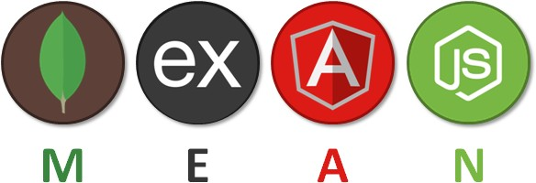

## MONGODB - 4.4.0

MongoDB is an open source NoSQL database management program. NoSQL is used as an alternative to traditional relational databases. NoSQL databases are quite useful for working with large sets of distributed data. MongoDB is a tool that can manage document-oriented information, store or retrieve information.

MongoDB supports various forms of data. It is one of the many nonrelational database technologies that arose in the mid-2000s under the NoSQL banner - normally, for use in big data applications and other processing jobs involving data that doesn't ﬁt well in a rigid relational model. Instead of using tables and rows as in relational databases, the MongoDB architecture is made up of collections and documents.



Organizations can use MongoDB for its ad-hoc queries, indexing, load balancing, aggregation, server-side JavaScript execution and other features.

## EXPRESS JS - 4.17.2

Express is a minimal and ﬂexible Node.js web application framework that provides a robust set of features to develop web and mobile applications. It facilitates the rapid development of Node based Web applications. Following are some of the core features of Express framework −

* Allows to set up middlewares to respond to HTTP Requests.
* Deﬁnes a routing table which is used to perform different actions based on HTTP Method and URL.
* Allows to dynamically render HTML Pages based on passing arguments to templates.

Since it is a framework of Node.js , most of the code is already written for programmers to work with. You can build a single page, multi-page, or hybrid web applications using Express.js. Express.js is lightweight and helps to organize web applications on the server-side into a more organized MVC architecture.



## ANGULAR - 13.2.1

Angular is a development platform, built on TypeScript. As a platform, Angular includes:

* A component-based framework for building scalable web applications
* A collection of well-integrated libraries that cover a wide variety of features, including routing, forms management, client-server communication, and more
* A suite of developer tools to help you develop, build, test, and update your code

With Angular, you're taking advantage of a platform that can scale from single-developer projects to enterprise-level applications.

Angular is designed to make updating as straightforward as possible, so take advantage of the latest developments with a minimum of effort. Best of all, the Angular ecosystem consists of a diverse group of over 1.7 million developers, library authors, and content creators.



## NODE JS 16.13.2 (LTS)

As an asynchronous event-driven JavaScript runtime, Node.js is designed to build scalable network applications. In the following "hello world" example, many connections can be handled concurrently. Upon each connection, the callback is ﬁred, but if there is no work to be done, Node.js will sleep.

This is in contrast to today's more common concurrency model, in which OS threads are employed. Thread-based networking is relatively inefﬁcient and very difﬁcult to use. Furthermore, users of Node.js are free from worries of dead-locking the process, since there are no locks. Almost no function in Node.js directly performs I/O, so the process never blocks except when the I/O is performed using synchronous methods of Node.js standard library. Because nothing blocks, scalable systems are very reasonable to develop in Node.js.



# FEATURES

## ADMIN DASHBOARD

1. Login
2. Add Patients into list.
3. Remove Patient into list.
4. View Doctors.
5. Apply for service
6. About us page.



# ANGULAR CONCEPTS USED

* Each Dashboard is in a different module
* Lazy loading for the different modules
* Reactive Forms to handle form data with validation
* Template Forms.
* Role Guards.
* Routing

# LIBRARIES USED

* Ng-bootstrap - 11.0.0
* Ng-fontawesome - 5.15.4
* Mongoose - 6.2.0
* Multer - 1.4.4
* Express - 4.17.2
* Cors - 2.8.5
* Angular Material - 13.2.1



# ARCHITECTURE DIAGRAM

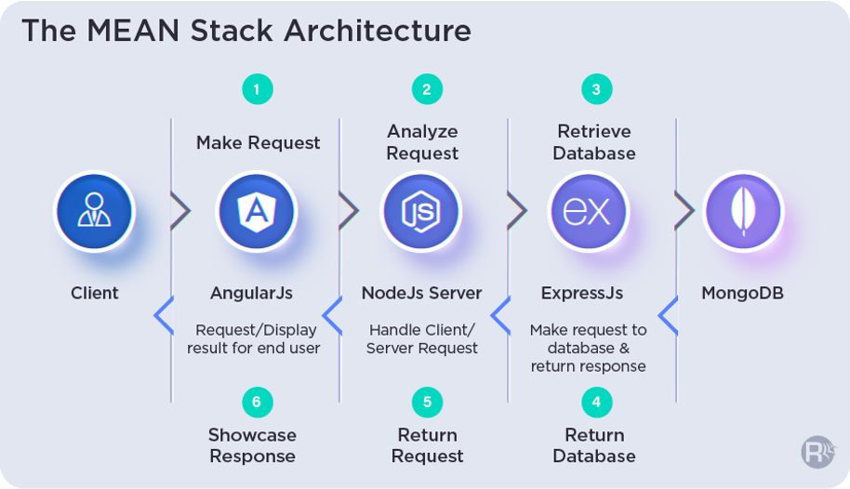

# COMPONENT DIAGRAM

